AI-Ready Brand Blueprint™
A comprehensive business intelligence framework for AI optimization
Welcome to your AI-Ready Brand Blueprint™ by Ford Saeks. This word document makes it easy to COPY/PASTE and Customize for YOUR BUSINESS.
This your strategic guide to ensuring consistency and alignment across all branding, messaging, and AI-training initiatives. Whether you're training AI language models, creating CustomGPTs, launching Claude Projects, or building Perplexity Spaces, this blueprint will help you achieve clear and effective communication.
How to Use This Document
This blueprint is designed to be a living document. Use it to:
- Train AI Models: Ensure your AI reflects your unique brand voice, customer profiles, and key messaging.
- Customize Campaigns: Tailor AI solutions for specific products, services, or campaigns.
- Collaborate: Share this guide with your marketing, sales, and AI development teams for consistent execution.
- Update Regularly: Revisit and refine this document as your business strategies, offerings, and market conditions evolve.
Quick Start Guide:
- Spend at least 15 minutes on Business Identity Elements.
- Move to Ideal Client Profile (ICP) and complete the external attributes.
- Use the Pain Point Matrix to identify key challenges your clients face.
- Craft your Value Proposition using the provided formula.

Bonus AI Masterclass: Unleashing AI innovations for your
Visit ProfitRichResults.com/ai-training for additional resources, video tutorials, and tools to maximize the impact of your AI projects.
Let’s keep this a living document—your ultimate tool for seamless AI and marketing integration

AI-Ready Brand Blueprint™

PROMPT for PERPEXITY.ai:
Perform my business and industry research and Create a single, comprehensive document that defines all essential brand, sales, and marketing information about [Your Company Name]. This resource will be used to train AI models, CustomGPTs and onboard employees, ensuring consistent knowledge, messaging, and interaction standards throughout all customer touchpoints. Add it all categories and whatever you think I missed

Business Identity Elements
Fill in these foundational elements of your brand identity. Be concise and specific.
- Company Name:
- Mission Statement:
- Vision Statement:
- Core Values (3-5):
- Brand Voice Characteristics:
- Brand Personality Traits:
- Industry Category/Vertical:

Brand Guidelines
Define the visual and tonal elements of your brand.
- Color Codes
- Typography
- Image Style Guide
- Tone of Voice Examples
- Writing Style Rules

Core Components
Revenue Model
- Primary income streams (e.g., product sales, subscriptions, consulting services).
- Secondary or supporting revenue channels.
Products and Services
- List of products/services with brief descriptions.
- Unique Features: Highlight what sets each offering apart.
Digital Footprint
- Website(s): Include main URL and key subpages.
- Social Media Links: Add profiles.
- Online Reviews/Testimonials: Provide links to notable reviews or case studies.
Brand Guidelines
Define the visual and tonal elements of your brand.
- Color Codes:
- Typography:
- Image Style Guide:
- Tone of Voice Examples:

Ideal Client Profile (ICP)
Defining your ideal client ensures targeted marketing, relevant messaging, and strategic sales outreach.
Step 1: External Attributes
- Industry: Specify the customer’s industry.
- Vertical: Define the customer’s niche or specialization.
- Revenue/Profit: State the customer’s (projected) revenue and profit.
- Employee Size: Indicate the number of employees.
- Location: Specify the geographical region(s).
Step 2: Contextual Details
- Team Size: Describe the customer’s internal teams.
- Challenges: List key challenges the customer’s team faces.
- Technologies Used: Identify tools, platforms, or software employed.
- Short-Term Goals: Define 3-month objectives.
- Long-Term Goals: Define 12-month objectives.
- Problem Assessment Process: Describe how challenges are identified.
- Impact of Challenges: Explain effects on operations.
- Challenge Response Tactics: Note current solutions or strategies.
Step 3: Personas
- Job Title: Define the primary decision-maker’s title.
- Age (Range): Provide approximate age or range.
- Education Level: Specify educational background.
- Income: Estimate income level.
- Responsibilities: Summarize key responsibilities.

Value Proposition Framework
Clearly articulate your unique value and how you solve client problems.
- Core Offerings:
- Product/Service Categories:
- Unique Selling Propositions:
- Competitive Advantages:
- Success Stories/Case Studies:

Pain Point Matrix:
Instructions: For each major pain point, complete the following:
- Problem: [Specific Issue]
- Consequence: [Immediate Impact]
- Long-term Effect: [Future Implications]
- Emotional Trigger: [How it makes them feel]

Formula for Crafting a Value Proposition:
We help [target audience] achieve [desired outcome] by [unique solution].

Positioning and Sales Narrative Formula:
The Positioning and Sales Narrative Formula is a powerful tool for crafting compelling sales messages that resonate with your ideal clients. Here's an explanation of why it's effective and how to use it:
Why This Formula Works
- Problem Recognition: Start with the client's challenges.
- Emotional Connection: Describe the consequences.
- Solution Framing: Present your offering as the solution.
- Benefit Articulation: Highlight the positive outcomes.

COMPLETE THIS FOR EACH ICP IN YOUR BUSINESS
1. PROBLEM/CONSEQUENCES:
Well you know how, (ICP ideal client profile) struggle with (PROBLEMS) ______, ______, _______, which causes (effects (emotional or financial) _________, ________, ________)….
Get’s the prospect to say YES I agree
2. RESULTS:
What we do (I do), is help (ICP_______) solve ___________, __________, __________, which results in (BENEFITS) __________, ________, ___________.
Get the to say… Yes, I need That… How do you do it?
Example:
PROBLEM/CONSEQUENCES:
Well you know how, small business owners struggle with implementing AI technologies, staying competitive in a rapidly changing market, and managing operational costs, which causes stress and anxiety, reduced profit margins, and the risk of falling behind industry leaders.... Get's the prospect to say YES I agree
RESULTS:
What we do is help small business owners solve AI implementation challenges, enhance market competitiveness, and optimize operational efficiency, which results in increased productivity, higher profit margins, and a strong competitive advantage in their industry. Get them to say... Yes, I need That... How do you do it?

Probing Questions Library for Each ICP
Asking the right questions is key to uncovering your clients' needs, challenges, and goals. Use this section to capture questions that you use during prospecting, discovery and selling.

Conversion Language Bank
Compile powerful language to use in marketing and sales communications.

Keyword-Rich Bios (Company and/or Individual)
Short Version (150-200 words):
Summarize your brand or individual expertise, emphasizing industry keywords.
Long Version (500 words):
Expand on your expertise, achievements, and unique value proposition.

SEO & Content Foundation: Keyword Phrases List
To identify emerging trends and other high-performing keywords, use these tools:
- Perplexity.ai – This AI-powered search tool provides insights into trending topics and commonly searched phrases, helping to uncover new keyword opportunities.
- AnswerThePublic.com – A research tool that generates commonly asked questions and search queries related to customer experience, consulting, and AI integration.

SEO & Content Foundation
Keyword Categories
- Primary Keywords
- Long-tail Variations
- Industry-specific Terms
- Question-based Searches
Magic Words & Phrases
- Power Words for Headlines
- Emotional Trigger Phrases
- Objection Handling Scripts

Company Narrative
- Origin Story
- Founder's Journey
- Mission Evolution
- Impact Stories
Social Proof Repository
- Client Testimonials
- Success Metrics
- Awards & Recognition
- Industry Credentials
- Partnership Badges
- Case Study Format
Communication Templates
- Email Sequences
- Social Media Posts
- Sales Scripts
- Customer Service Responses
- Messaging Templates for Outreach
- Template for comparing services
- Focus on differentiators

Bonus Tips:
- Keep the document dynamic: Update with changes in strategy, offerings, or market conditions.
- Prioritize clarity and alignment: Ensure all teams (sales, marketing, AI developers) use the same language

BONUS PROMPTS:
BUYER JOURNEY MAPPING
Act as a buyer psychology expert. My business is [INSERT BUSINESS]. Map out the complete buyer journey and, for each stage (Awareness, Consideration, Decision, Post-Purchase), list the exact questions my ideal client might be typing into Google or asking colleagues. Present the results in a table with columns: Stage, Question, Emotional Driver, Suggested Content/Offer

COMPETITOR MINING
Act as a competitive intelligence analyst. My business is [INSERT BUSINESS]. Research my top 5 competitors and list 25 questions their customers are asking that I could answer better or differently. Organize them by topic and mark each one as: Quick Win, Needs Effort, or High ROI.

SOCIAL LISTENING
Act as a social listening and trends analyst. My business is [INSERT BUSINESS]. Pretend you have access to the latest social media, forum, and Q&A site discussions. Identify the most common frustrations, myths, and misunderstandings people have right now about this topic. List them as questions they'd likely ask, then suggest a hook or headline idea for each question that could grab attention online.

OVERCOMING OBJECTIONS
Can you help me craft responses to handle COMMON OBJECTIONS to my services, like 'Your services are too expensive,' 'We don’t have the budget,' and 'We can get the same results for less elsewhere'? I want to address their concerns confidently while highlighting the value we bring. Additionally, how can I preemptively minimize objections during my sales process?

Ford Saeks is a business growth accelerator with a proven track record of helping organizations generate over $1 billion in sales.
For decades, he has guided leaders, entrepreneurs, and teams to achieve measurable results by focusing on practical strategies that streamline operations, boost performance, and drive growth.
As an expert in AI integration and business strategy, Ford is known for cutting through the noise to deliver actionable insights that drive real impact. In AI Mindshift, he shares the tools and strategies businesses need to leverage AI, reduce costs, and stay competitive—while maintaining the human touch that sets them apart.
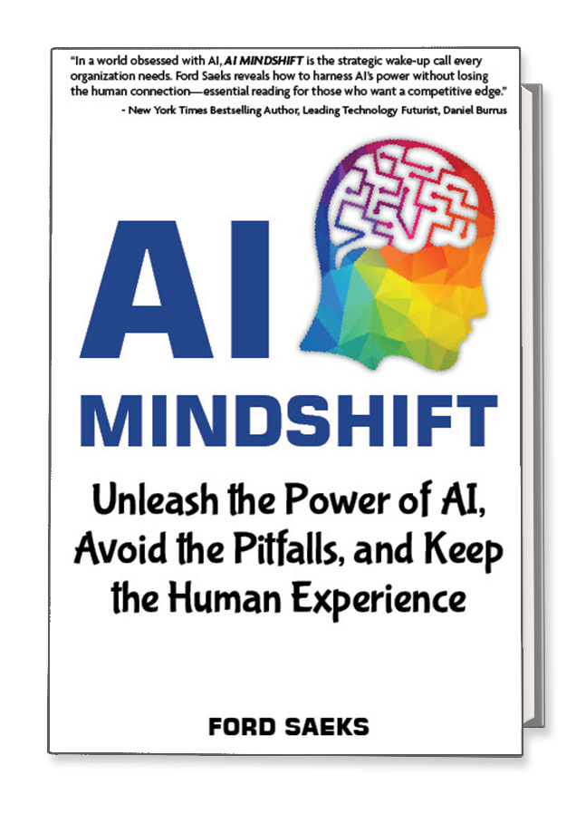
AI Mindshift isn’t just about technology—it’s about results.
This practical guide shows you how to harness artificial intelligence to drive growth, improve efficiency, and outpace the competition.
For business owners, entrepreneurs, and leaders, this book delivers the strategies and insights to:
Streamline operations for maximum productivity
Attract and retain customers with AI-powered tools
Reduce costs while preserving quality and the human touch
Innovate faster with AI-driven decision-making
Packed with real-world examples and actionable steps, AI Mindshift unlocks the potential of AI to deliver measurable results—fast.
